Chapter 10, Solution 76.

Determine V_{o} and I_{o} in the op amp circuit of Fig. 10.119.

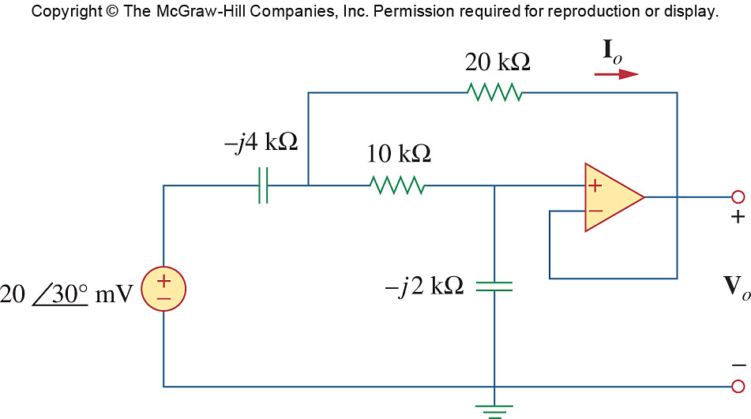
2∠30° V

Figure 10.119
For Prob. 10.76.

Solution

Let the voltage between the -jk capacitor and the 10k resistor be V_{1.}

(1)
= 1.7321+j1

Also,
(2)

Solving (2) into (1) yields

= (4+j5)V_{o}

= 312.4∠–21.34˚ mV

I_{o} = (V₁–V_{o})/20k = V_{o}/(–j4k) = (0.3124/4k)∠(–21.43+90)˚

= 78.1∠68.57˚ µA

We can easily check this answer using MATLAM. Using equations (1) and (2) we can identify the following matrix equations:
YV = I where

>> Y=[1-0.6i,0.6i;1,-1-0.5i]

Y =
1.0000 - 0.6000i 0 + 0.6000i
1.0000 -1.0000 - 5.0000i

>> I=[1.7321+1i;0]

I =
1.7321 + 1.0000i
0

>> V=inv(Y)*I

V =
0.8593 + 1.3410i
0.2909 - 0.1137i = V_{o} = 312.3∠–21.35˚ mV. The answer checks.

